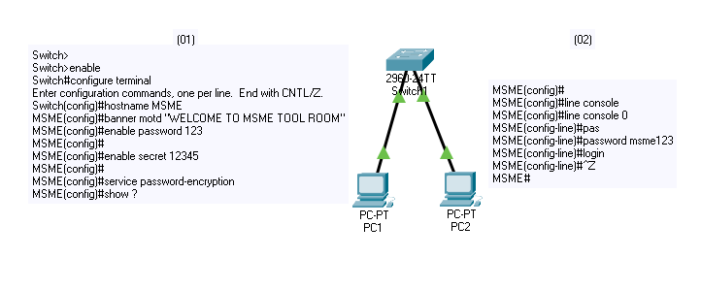

Switch> **(User Executive Mode)**

Switch>enable

Switch# **(Privileged Mode)** idaa

Switch#configure terminal

Enter configuration commands, one per line. End with CNTL/Z.

Switch(config)# **(Global Configuration Mode)**

Switch(config)#hostname MSME **(To Set Hostname)**

MSME(config)#

MSME(config)#banner motd "WELCOME TO MSME TOOL ROOM" **(Set Welcome Message)**

MSME(config)#

MSME(config)#enable password 123 **( To Set Password for Configuration)**

MSME(config)#

MSME(config)#enable secret 12345 **( To Set Secret ‘password’ for Configure above Password)**

MSME(config)#

MSME(config)#service password-encryption **(To hide passwords and configuration)**

MSME(config)#

MSME(config)#? **(To See Commands in that mode)**

Configure commands:

MSME(config)#

MSME(config)#line console 0 **(To set password in console post)**

MSME(config-line)#password msme123 **(write password as you want)**

MSME(config-line)#login **(Write ‘login’ command to activate password)**

MSME(config-line)#^Z **( for go back in privileged mode)**

MSME#

%SYS-5-CONFIG_I: Configured from console by console

MSME#write **(To save configuration)**

Building configuration...

[OK]

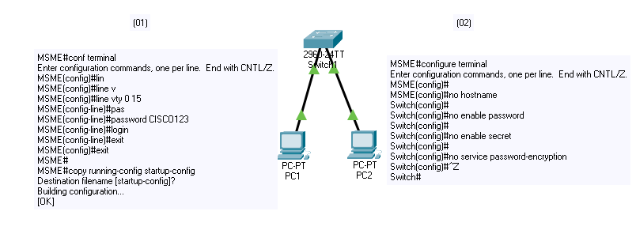

MSME#

MSME#conf terminal

Enter configuration commands, one per line. End with CNTL/Z.

MSME(config)#

MSME(config)#line vty 0 15 **(To set password for remote access or config)**

MSME(config-line)#password CISCO123 **(Write password as you want)**

MSME(config-line)#login **(Write ‘login’ command to activate password)**

MSME(config-line)#exit **( for go back)**

MSME(config)#exit

MSME#

%SYS-5-CONFIG_I: Configured from console by console

MSME#

MSME#copy running-config startup-config **(To save configuration)**

Destination filename [startup-config]?

Building configuration...

[OK]

MSME#

MSME#configure terminal

Enter configuration commands, one per line. End with CNTL/Z.

MSME(config)#

MSME(config)#no hostname **(To remove hostname)**

Switch(config)#

Switch(config)#no enable password **(To remove enable password)**

Switch(config)#

Switch(config)#no enable secret **(To remove enable secret)**

Switch(config)#

Switch(config)#no service password-encryption **(To remove service password-encryption)**

Switch(config)#

CISCO(config)#line console 0 **(To set password in console post)**

CISCO(config-line)#password cisco123 **(write password as you want)**

CISCO(config-line)#login **(Write ‘login’ command to activate password)**

CISCO(config-line)#exit **( for go back)**

CISCO(config)#

CISCO(config)#line vty 0 15 **(To set password for remote access or config)**

CISCO(config-line)#password cisco12345 **(Write password as you want)**

CISCO(config-line)#login **(Write ‘login’ command to activate password)**

CISCO(config-line)#exit **( for go back)**

CISCO(config)#^Z

Switch(config)#^Z

Switch#write **(To save configuration)**

%SYS-5-CONFIG_I: Configured from console by console

Switch#

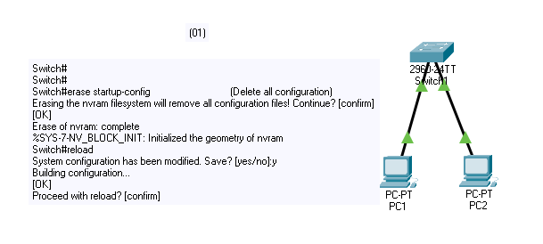

Switch#

Switch#

Switch#erase startup-config **(Delete all configuration)**

Erasing the nvram filesystem will remove all configuration files! Continue? [confirm]

[OK]

Erase of nvram: complete

%SYS-7-NV_BLOCK_INIT: Initialized the geometry of nvram

Switch#reload

System configuration has been modified. Save? [yes/no]:y

Building configuration...

[OK]

Proceed with reload? [confirm]